

Predicting EmiratiTel Churn using Machine Learning

Asma Alkarbi – H00492811
Afraa Almessabi – H00492723
Maryam Salem Alshouq – H00492571

CDS 4003 Data Science for Business Applications
Dr. Zamhar Ismail
Higher Colleges of Technology

Table of Contents
1. Introduction 3
1.1. Customer Churn 3
1.2. Objectives of Eliminating Churn 3
2. Business Understanding 3
2.1. Business problem 3
2.2. Business Success Criteria 4
2.3. Model Success Criteria 5
3. Data Understanding 5
3.1. Dataset Overview 5
3.2. Key Observations 6
4. Target Variable 9
5. Features Description 9
6. Data Preparation in RapidMiner 11
6.1. Data Loading 11
6.2. Data Cleaning 13
6.3. Data Preprocessing 14
6.4. Encoding 23
6.5. Final touches 25
7. Cleaned Dataset 27
8. Post cleaning 27
9. Summary of Data Preparation 28
10. Model Development 29
10.1. Steps in RapidMiner 29
10.2. Logistic Regression 32
10.3. Random Forest 34
11. Performance Evaluation 36
11.1. Confusion Matrix 36
11.2. Accuracy 36
11.3. Precision 37
11.4. Recall 37
11.5. F1-Score 37
11.6. AUC 37
12. Model Comparison 39
13. Business Insights 40
14. Recommended Actions 41
15. Deployment Strategy 41
15.1. Real Time or Batch 41
15.2. Integration with CRM 42
15.3. Monitoring 42
16. Conclusion 43
17. References: 44

Introduction

Customer Churn
Customer churn is defined as losing a customer due to several factors, including customers turning to competitors for better opportunities. In a business, losing a customer means having to conduct what is known as ‘customer attrition analysis’ to keep existing customers, as this costs less than scouting for new ones (Wikipedia contributors, 2025b). In the telecommunications service providers industry, this is a constant problem they’ve been dealing with. As the years pass, the industry has been more open to being put in a competitive environment, and customers see new technologies and lucrative offers. This churn problem causes loss at a large scale for the telecom service provider, and new efforts by companies are always in motion to tackle their churn rate from increasing (Huang et al., 2012).

Objectives of Eliminating Churn
Keeping customers from churning is critical as it financially affects the telecom company and its market share. Within the telecom space, there are always new businesses offering the latest services and technologies for better prices. This flood of new businesses makes customer retention more challenging. It is important to predict if a customer might churn as that has become a new standard practice within telecom companies. With these predictions, they’re able to anticipate and bring customers closer. With newfound technologies, these companies can now utilize ML and AI to their advantage, saving them costs and helping them meet their goals more efficiently (Deepika Kumari et al., 2025).

Business Understanding

Business problem
EmiratiTel has a difficult time with customer retention, where many of their customers churn. This has many reasons, it could be because of competitors offering better deals or the company itself faces internal issues which spill over into quality of service like poor decision making relating to prices where prices are outrageous, for example. Churn costs EmiratiTel a fortune and drains resources for customer acquisition. The company wants to identify customers who are at a high risk of churning to take proactive measures. The goal of this project is to develop a ML model that predicts customer churn for EmiratiTel and helps the company in taking proactive measures to reduce churn rate.
Business Questions:
1. What are the most churnable customers?
This assists EmiratiTel to determine high risk customers and implement proactive retention measures.
2. What are the most important customer churn factors?
The knowledge of these factors assists in enhancing pricing, services, and customer satisfaction.
3. What can EmiratiTel do to decrease churn with predictive analytics?
This helps in data-driven approaches in order to retain more customers and cut expenses.

Business Success Criteria
The effectiveness of the machine learning model in helping to realize the business goals, as well as enhancing customer retention, will be used to measure the success of this project. The success criteria are:
- Achieving a reduction in customer churn by approximately 10–15%, through early identification of high-risk customers.
- Reducing cost of customer acquisition through the need to replace lost customers being minimal resulting in the estimated cost savings.
- Increasing customer retention by 10-20% with specific retention measures.
- Growing the customer base who are on long-term contracts (annual plans) through loyalty and churn.
- Improving marketing effectiveness through re-investment of resource saved in personalized campaigning and customer engagement strategies.

Model Success Criteria
The machine learning model will be tested in the context of its predictive power to customer churn and aid in business decision making once it is found to be successful. The most important model success criteria are:
• Obtaining a level of accuracy which will give a reliable generalization of the churn and non-churn customers.
• Achieving a recall score of at least 70% of churn customers, so that majority of high-risk customers are not missed.
• A combination of a moderate level of both accuracy and recall (high F1-score) to minimize false positives and false negatives.
• An AUC (Area Under the Curve) of at least 0.75, which is a good model capability to differentiate between churn and non-churn customers.
• Differentiating the top 20 percent of customers most likely to churn, enabling the business to concentrate on retention efforts.
These criteria make sure that the model is technically correct but also business-oriented so that it could be used to make effective and fact-based decisions.

Data Understanding

Dataset Overview
The dataset for this project contains information about EmiratiTel customers and their service usage. Each observation in the dataset represents a customer, and the columns are features detailing the customer's behavior and interactions with the company. The dataset consists of independent features and a dependent target, which in this case is churn. The features define client characteristics, while the goal variable shows whether or not the customer has churned. This dataset will be used to train machine learning models that can recognize patterns and predict future churn.
Moreover, the dataset consists of about 7043 records and 21 features with both categorical and numerical variables. The features include customer details, service packages and billing details including MonthlyCharges and TotalCharges.
In the early stages of exploration, a few data quality problems were detected, such as the lack of values and discrepancies in certain columns. All these problems needed the process of cleaning and preprocessing data prior to the usage of machine learning models.
Moreover, the data is somewhat skewed, as there are more non-churn customers than churn customers, and it is essential to apply the relevant evaluation measures like recall and AUC.

Key Observations
The following insights were derived from a brief look at the dataset mixed with domain knowledge about telecom churn datasets and patterns in general. Some noticeable details to point out regarding the dataset are:

Customers with a lower tenure have a higher chance of churning.
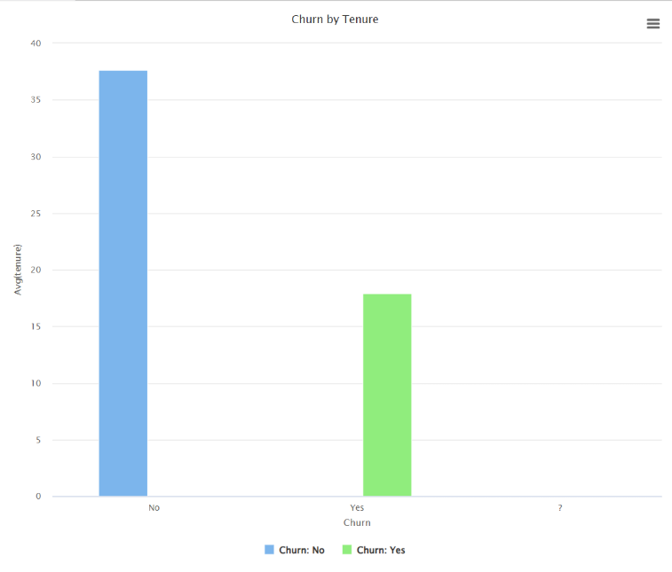
MonthlyCharges high pricing is a major contributer in churn.
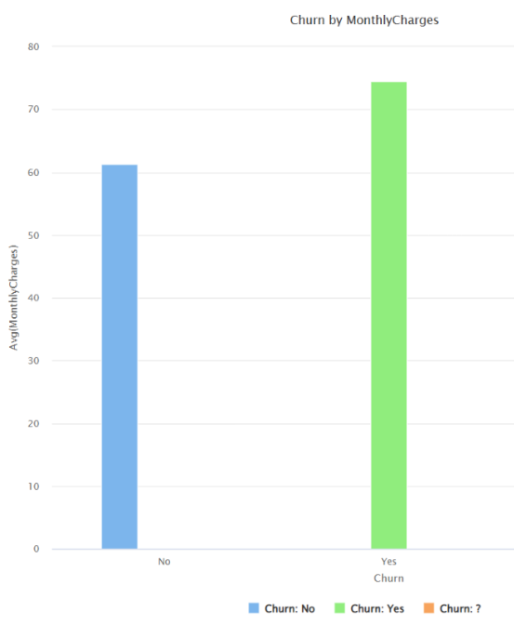
Customers using automatic payment are more likely to stay and find more stability.
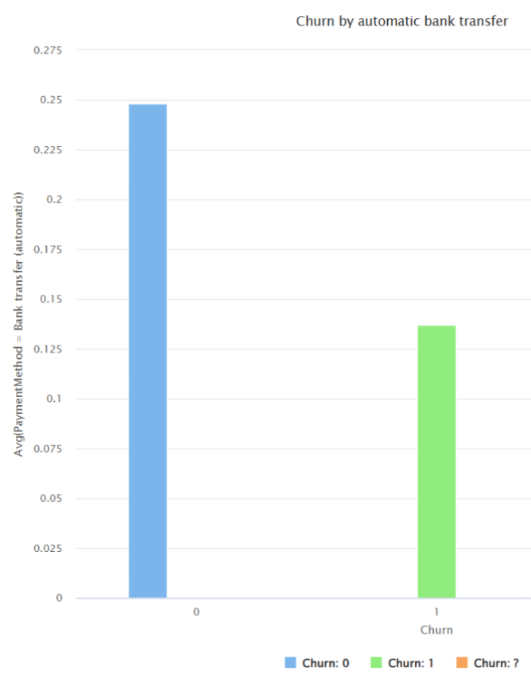
Customers using fiber optic-based internet are more likely to churn, as it is more expensive.
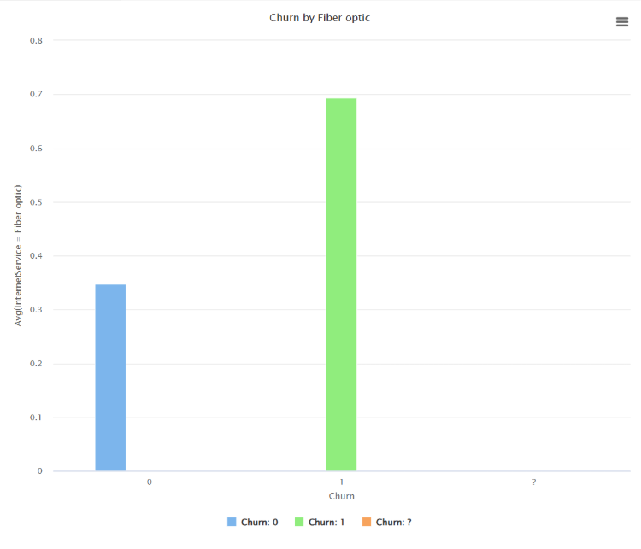
Customers without dependents are more likely to churn due to lower responsibility, as they don’t have long-term commitments.
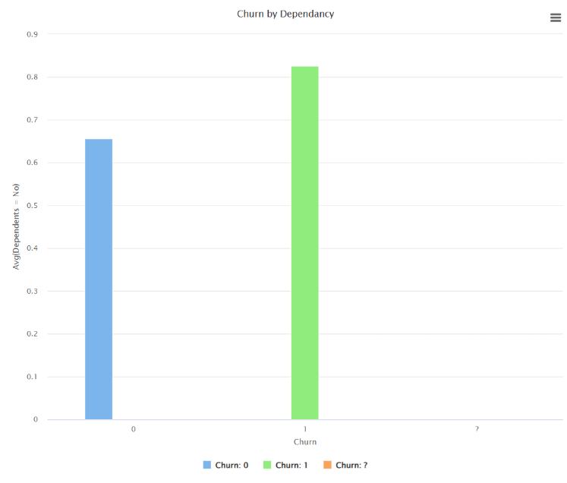

Target Variable
The project's target variable is Churn.
This variable describes if a consumer has stopped using EmiratiTel services completely.
- If Churn is at “Yes”, it means the customer has left EmiratiTel for a variety of reasons.
- If Churn is at “No”, this means that the customer is still using EmiratiTel services.
The machine learning model aims to predict this variable based on other consumer characteristics.

Features Description
The dataset contains information about EmiratiTel customers which range from services to demographics, to payment details and finally the target variable “Churn”. This is a historic dataset which the model will use to study patterns and later apply that knowledge to new and unseen data. The features include:
Feature name | Description | Example
customerID | Unique identifier for each customer | 7310-EGVHZ
gender | Female or Male | “Female”, “Male”
SeniorCitizen | Whether the customer is a senior citizen or not | 1 = yes, 0 = no
Partner | Whether the customer is married or not | "Yes”, “No”
Dependents | Whether the customer is legally responsible for the care of certain individuals or not | "Yes”, “No”
Tenure | Number of months the customers stayed | 1 (one month), 2 (two months), etc...
PhoneService | Whether the customer has a phone service or not | “Yes”, “No”
MultipleLines | If a customer has multiple numbers or not (if they don’t its either because they don’t have a phone service in the first place or choose not to have multiple numbers) | “Yes”, “No”, “No phone service”
InternetService | Whether the customer has internet service or not, and if they do, what type of internet service do they have | “DSL”, “Fiber optic”, “No”
OnlineSecurity, OnlineBackup, DeviceProtection, TechSupport, StreamingTV, StreamingMovies | Whether the customer is paying for any of these internet-dependent services, choosing not to pay, or not having an internet service at all | “Yes”, “No”, “No internet service”
Contract | The contract which dictates when a customer should pay | “Month-to-month", “One year”, “Two years”
PaperlessBilling | Billing type | “Yes”, “No”
PaymentMethod | How the customer pays for services. Could be automatic like bank transfer and credit card, or manual like electronic check or mailed check | “Bank transfer (automatic)”, “Electronic check”, “Mailed check”, “Credit card (automatic)
MonthlyCharges | How much the customer pays per month | Price ranges from 18.25 to 118.75
TotalCharges | Total amount charged, calculated by multiplying MonthlyCharges with tenure | Price ranges from 18.80 to 8684.80

Data Preparation in RapidMiner

Data Loading
After using read excel, the first step was to declare customerID as the ID column by giving it the ID role.
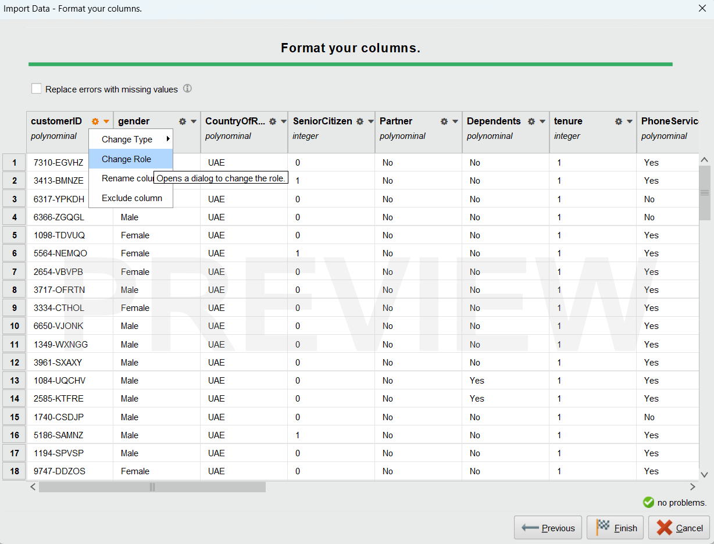
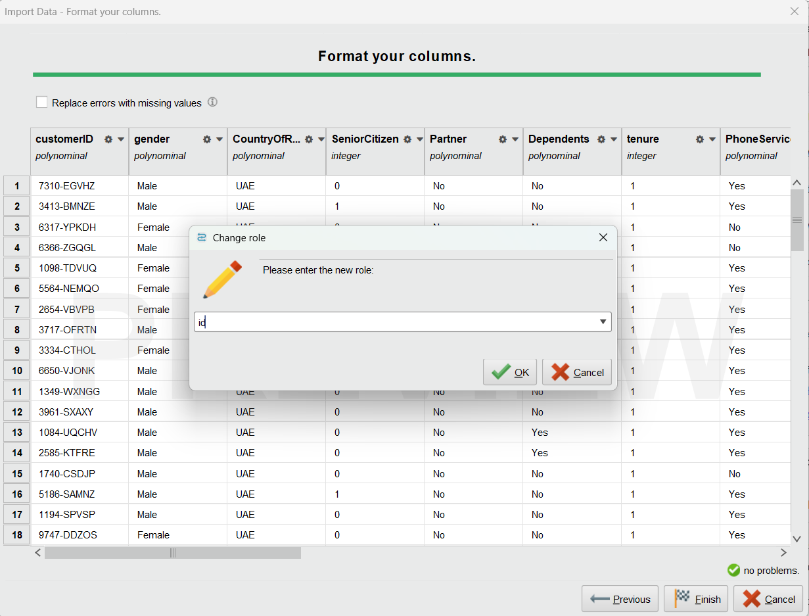
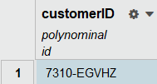

Data Cleaning
To detect missing & irregular values, we viewed the features from the statistics tab. This is what we found:
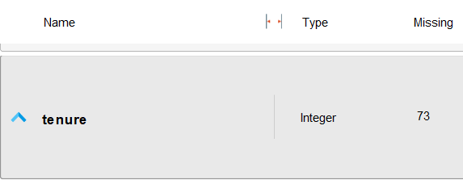
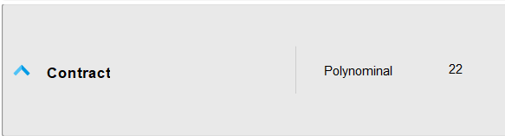
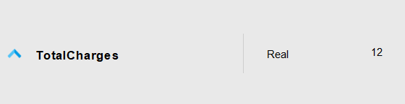


MonthlyCharges and TotalCharges had negative values:
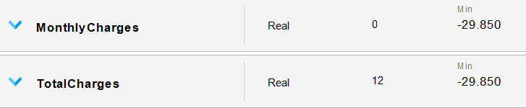

Other columns such as PhoneService, OnlineSecurity, OnlineBackup, DeviceProtection, TechSupport, StreamingTV, and Churn all had 1 missing value only.

Data Preprocessing

Some columns had 1 null value only, so these problem rows were dropped
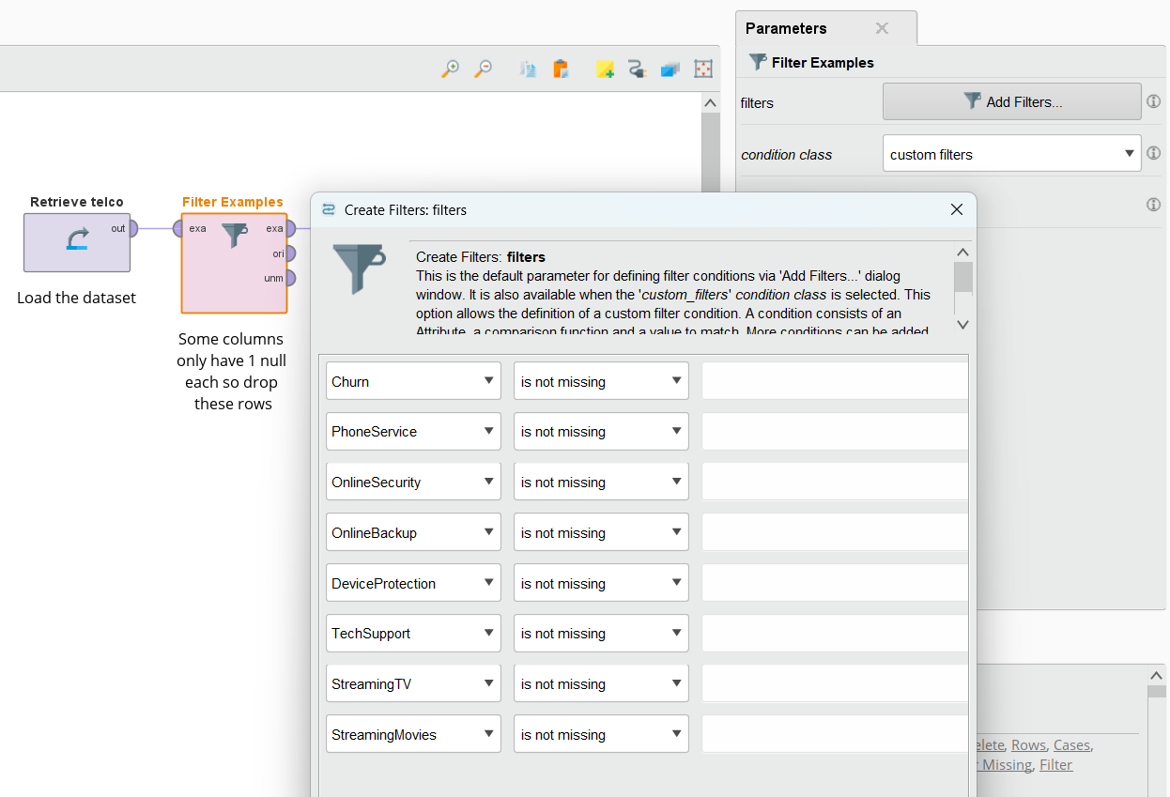

Replaced “No phone service” with “Unavailable phone service” forMultipleLines. This step was done so that in dummy encoding, the model doesn’t think that “No” and “No phone service” are the same due to both starting with “No”. Distinction between both matters because they are contextually different. “No phone service” means the user never got this service, while simply “No” means the user has a phone service but chose not to get MultipleLines.
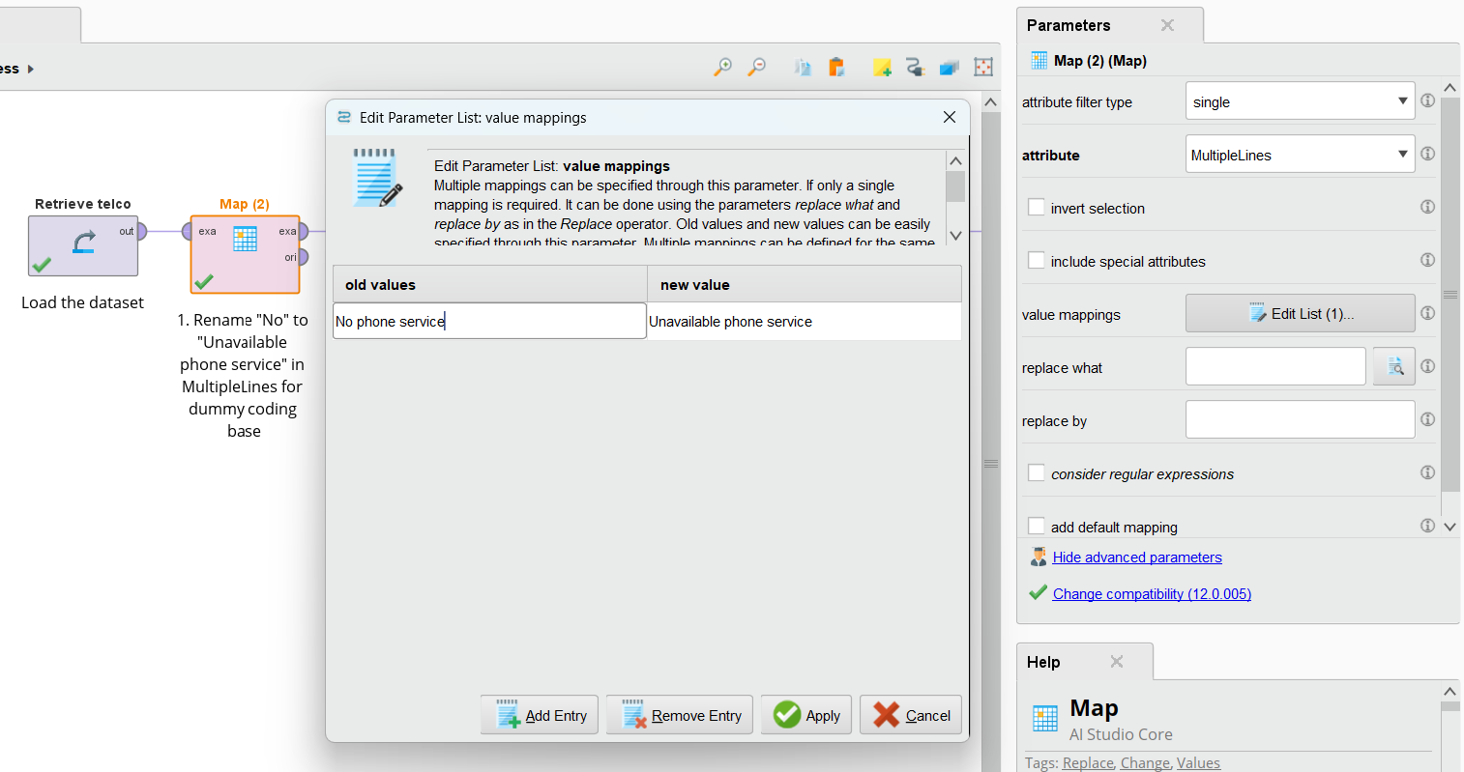

Replaced “No internet service” with “Unavailable internet service” for multiple columns. Same reasoning as above. Here, “No internet service” means the user never got an internet service and therefor cannot use services that require the internet, while simply “No” means the user chose not to get certain services.
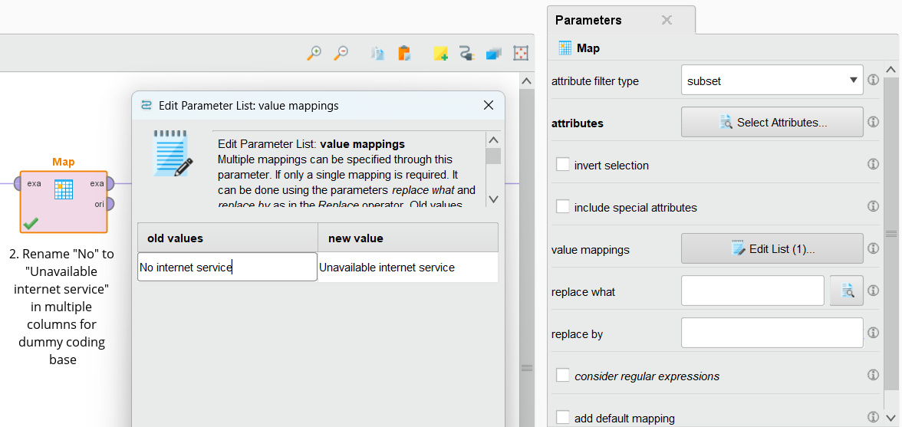
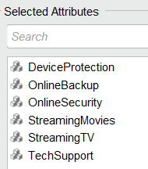
Now, the 3 categories are distinct and one of them will be used as the baseline for dummy encoding, so when the model sees all zeros, it knows that this sequence of zeros means baseline.

Converted churn to Binomial. This is done to support proper encoding, so the model doesn’t give importance like 1 > 0
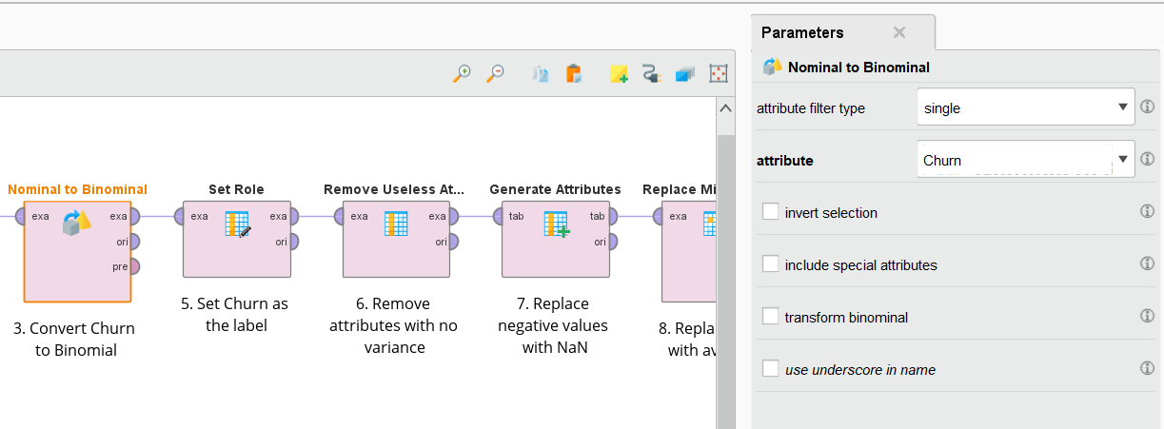

Set churn as the label; the value the model will aim to predict
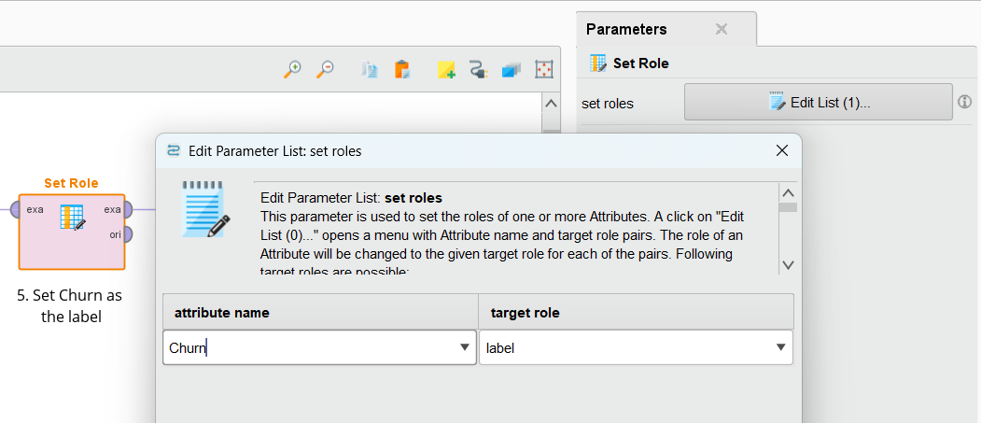

Removed CountryOfResidence as it has the same value without any variance
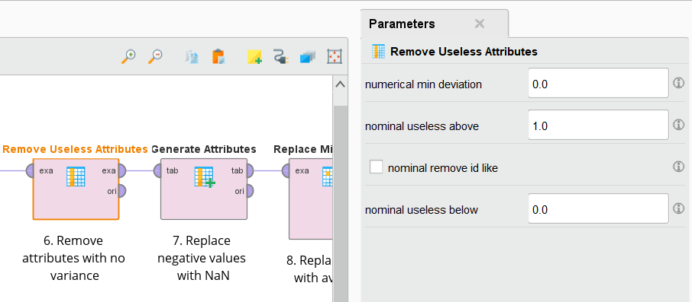

MonthlyCharges had negative values, so, to deal with them, the negative values were first converted to null
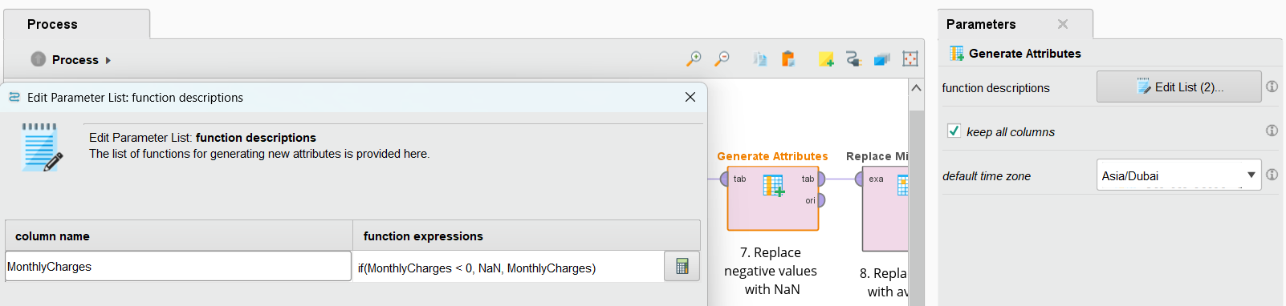

Replaced missing values with their averages to impute
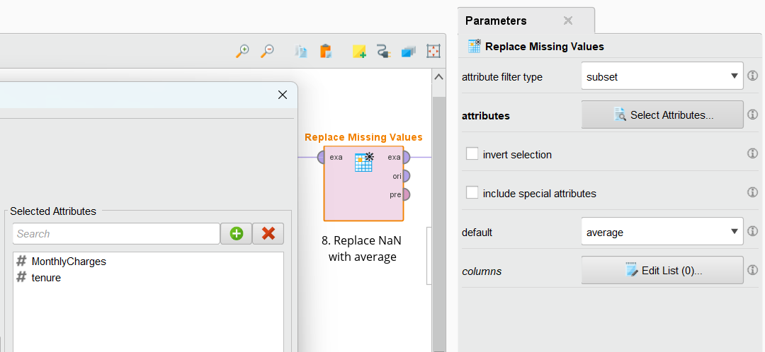

Imputed MultipleLines column with “No” as that is the most frequent value
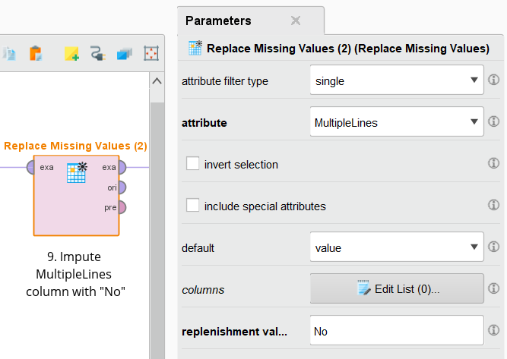

Imputed multiple columns whose most frequent value is “Yes” with that
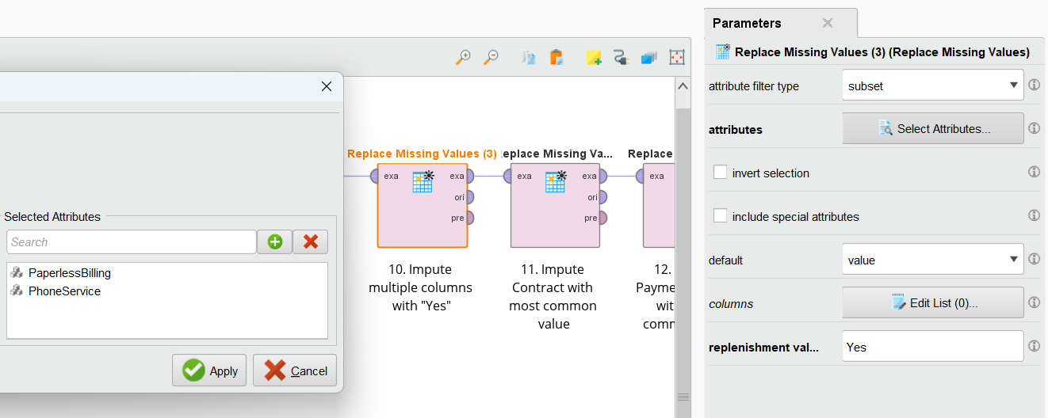

Imputed “Contract” with its most common value
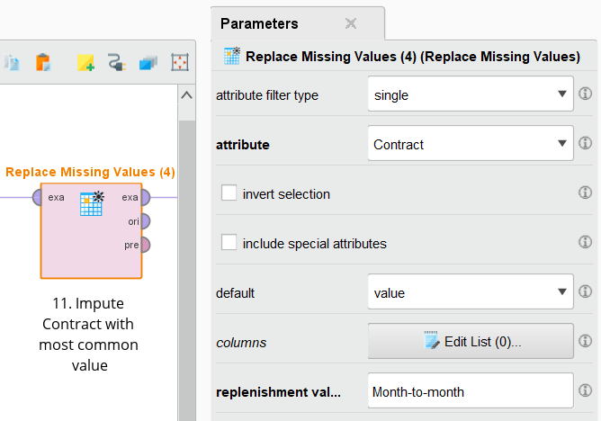

Imputed PaymentMethod with its most frequent value
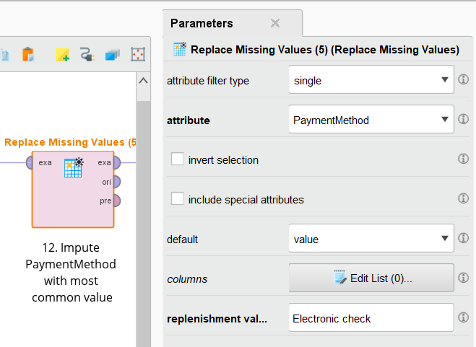

Replaced Male with M and Female with F for consistency
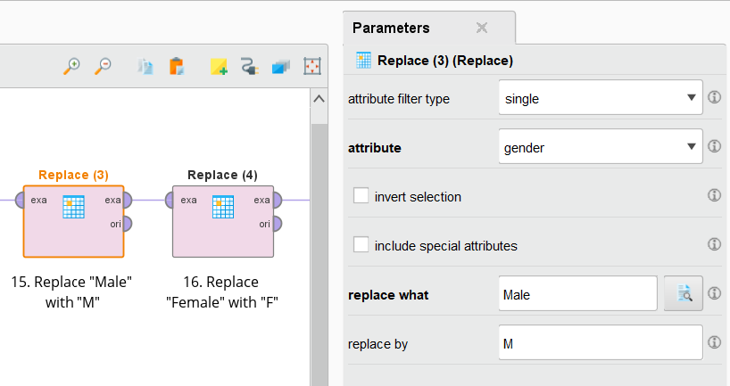

Capitalized the column names for consistency
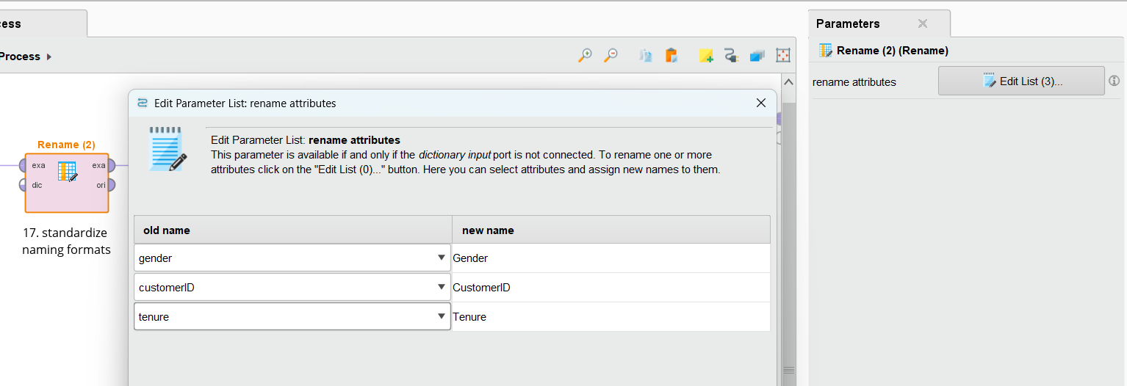

Encoding

The encoding used here was dummy encoding with “use comparison groups” enabled as a baseline.
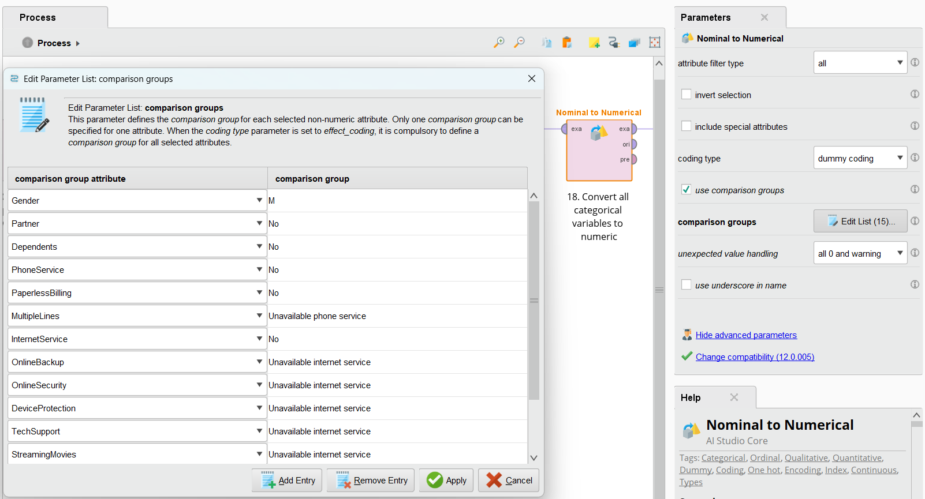
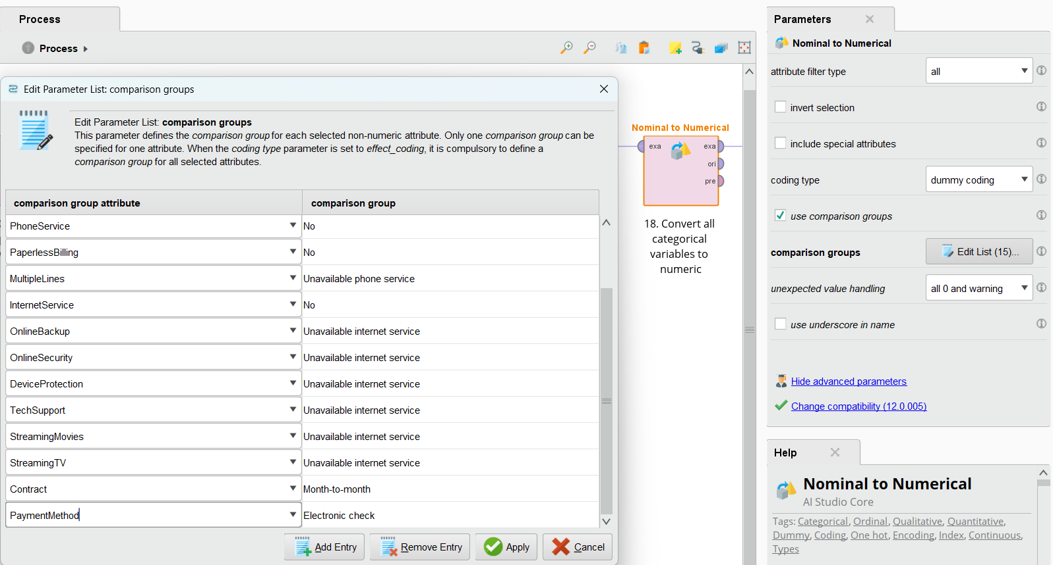

Used label encoding to encode Churn with “include special attributes” enabled as it was set to “label”
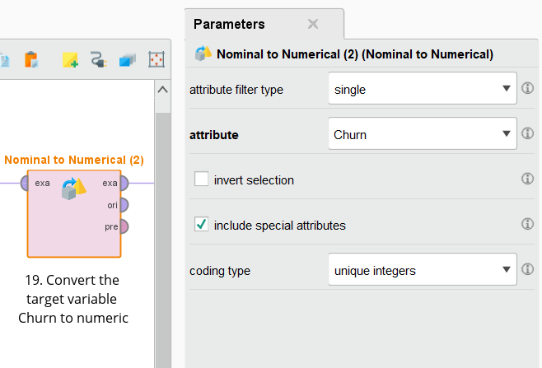

Final touches

Applied range transformation to the 2 continuous features for better results by the model
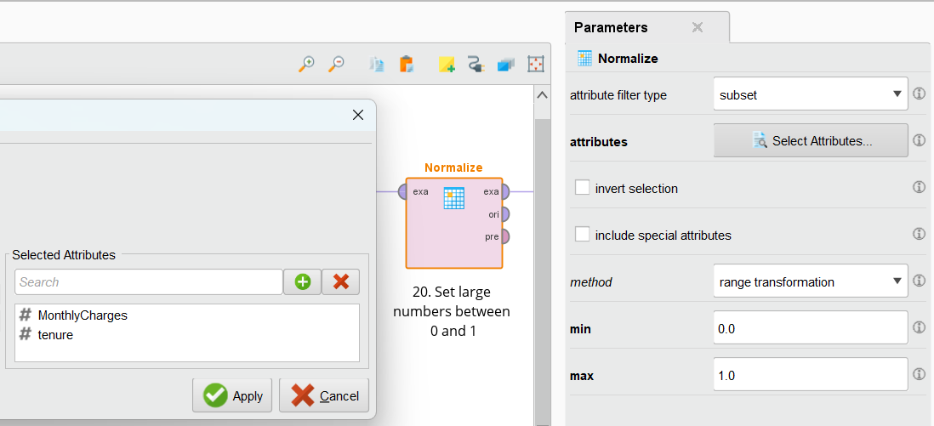

Excluded TotalCharges from the dataset as it is derived from both tenure and monthly charges and excluded other columns to avoid multicollinearity and a data leak which could inflate the model’s results.
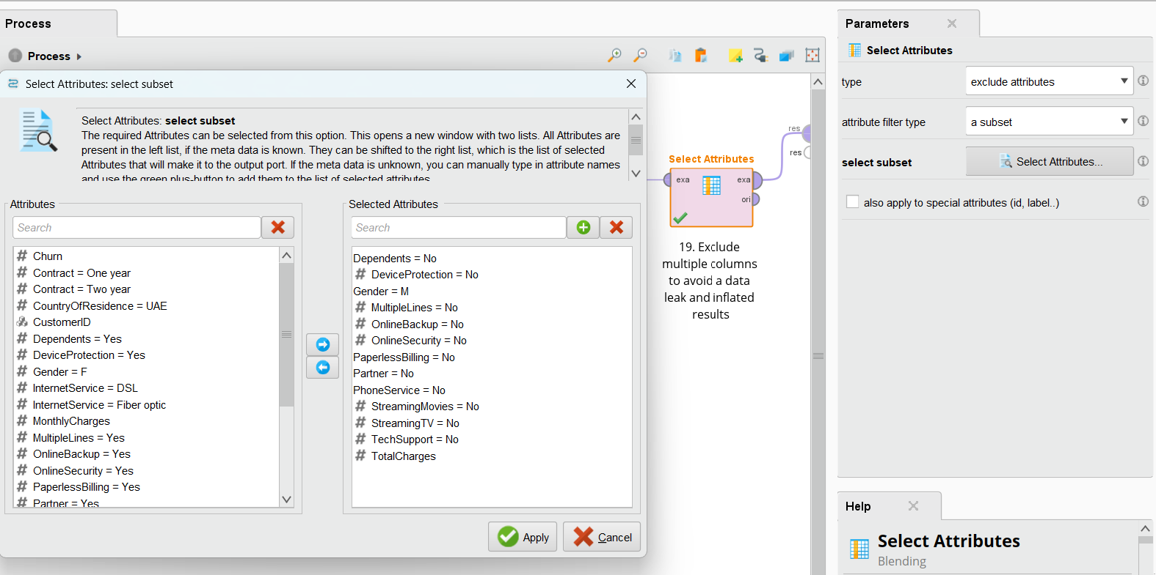

Cleaned Dataset

This is what the dataset looks like now after completing preprocessing. (dataset loaded using VS Code for better clarity)
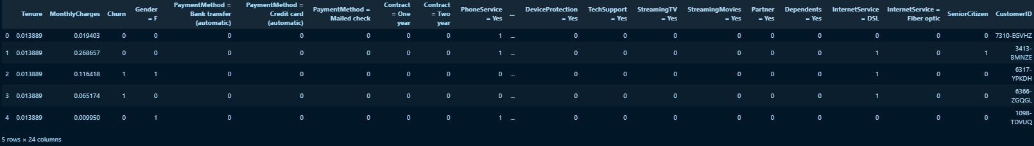

Post cleaning
After completing cleaning and preprocessing, the dataset is now consistent and fully ready for machine learning algorithms to use it. Null values were dealt with in multiple ways: dropping or imputing. Some observations were categorical so the null values were imputed with the most frequent value. Some observations had insignificant nulls like 1 observation only or 6, so these were dropped. Other observations came with negative values and thus had to be converted to null then imputed by mean. The next step was mapping certain values with new meanings. In Rapid Miner, "No" and "No internet service" for example have the same meaning, despite being contextually different. To combat this issue, "No internet service" was replaced with "Unavailable internet service". Next, churn was converted to Binomial as it only had churn or no, and logistic regression needs this distinction to perform better. Afterwards, churn was set as the label. Next, the CountryOfResidence was retried due to having 0 variance. This enhances the model's performance by removing unnecessary features. Then, to ensure consistency, values in the gender column were converted from "Male" and "Female" to M or F, and feature names were capitalized accordingly to match the naming format of surrounding features, so "tenure" for example became "Tenure". Next, came the encoding part. In encoding, dummy coding was used with comparison groups enabled to establish a baseline. So for example, the baseline for "DeviceProtection" was set to "Unavailable internet service" meaning if both DeviceProtection = Yes and DeviceProtection = No were zeros, it means this certain observation's DeviceProtection is "Unavailable internet service" as that equals to 00, as opposed to DeviceProtection = Yes which equals 1 followed by 0. As for Churn's encoding, the coding type was set to "unique integers" as a kin to "LabelEncoding" as per Rapid Miner's naming for that type of encoding. Finally, scaling by range transformation for the only 2 features MonthlyCharges and Tenure were applied to make sure Logistic Regression works properly, as it's good practice for values to be set in a range.

Summary of Data Preparation
During the first 3 phases of CRISP-DM, we talked about what customer churn is, why it’s bad, and what it is in the context of telecommunication. We defined success metrics for both the business and the model. Next, we analyzed the dataset by explaining features and the target variable. We also looked at key insights for the dataset; we explored things like causes of churn and who’s more likely to churn based on quick observations. Then, we applied detailed preprocessing to ensure the dataset is cleaned and ready for the ML. Now, the dataset is ready for the next step. The process executed here will later help reveal which customers are most likely to churn.

Model Development

Steps in RapidMiner
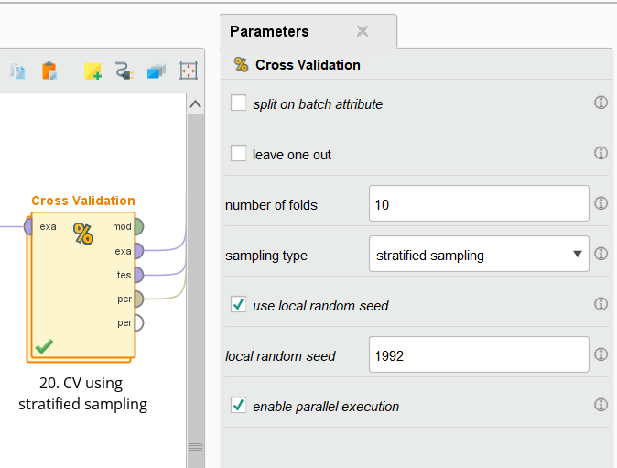
For the training part, we worked using cross validation. For the parameters of cross validation, we set the number of folds as 10 as per the requirements. As for the sampling type, we went with stratified sampling. This is because the dataset is highly imbalanced with most clients not churning, and stratified sampling ensures the same percentage for each class per fold and eliminates problems like overfitting. We enabled local random seed with the number 1992 to ensure the same data stays in every fold regardless of how many runs we do. For parallel execution, we enabled it to speed up the training process and make better use of the CPU.

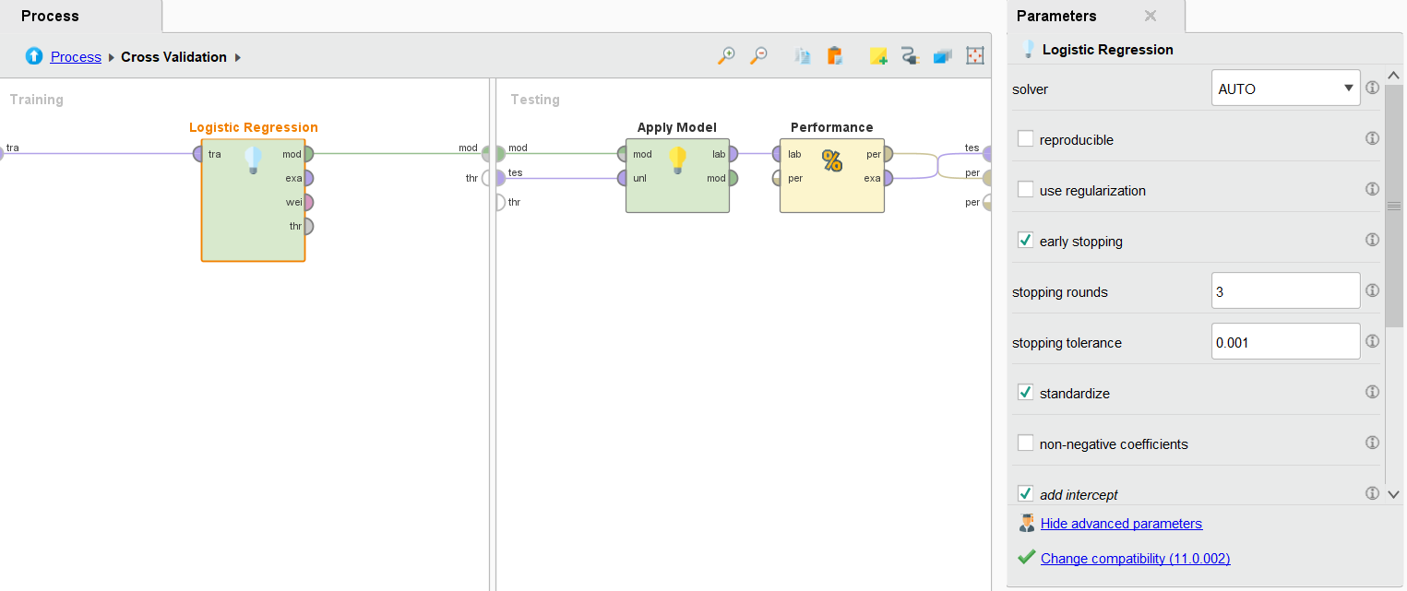
This is the process inside of cross validation. The model goes on the right for training and the left side contains everything related to testing. Apply model here is used to take the training data and apply testing. The output of apply model goes into performance for evaluation. The final output is the performance.
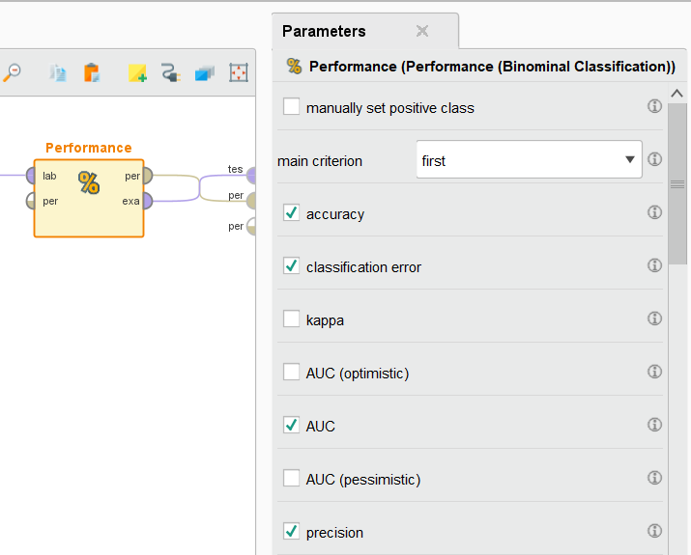
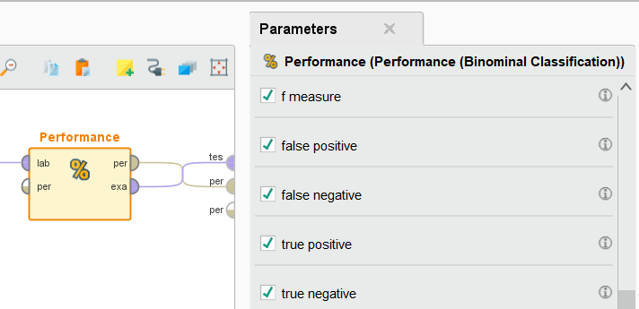
The following screenshots demonstrate enabled parameters for performance. These include:
- Accuracy: shows the % of correct churn predictions. Meaning how many churned and were predicted correctly.
- Classification error: the percentage of all incorrect predictions, including both FP and FN.
- AUC: also called area under curve. This parameter shows how well the model separates churn vs no churn.
- AUC: also called area under curve. This parameter shows how well the model separates churn vs no churn.
- Precision: this metric shows how correct the model was in predicting churn when they actually churned.
- F1 score: this metric is the balance between precision and recall. If the overall churn predictions are correct, this score should be high.
- False positive: this means the model incorrectly predicted churn when the client didn’t churn. FP is classified as type 1 error.
- False negative: this means the model incorrectly predicted a churned client as not churn. FN is classified as type 2 error.
- True positive: model predicted churn and the client actually churned.
- True negative: model predicted not churn and the client actually didnt churn.

Logistic Regression

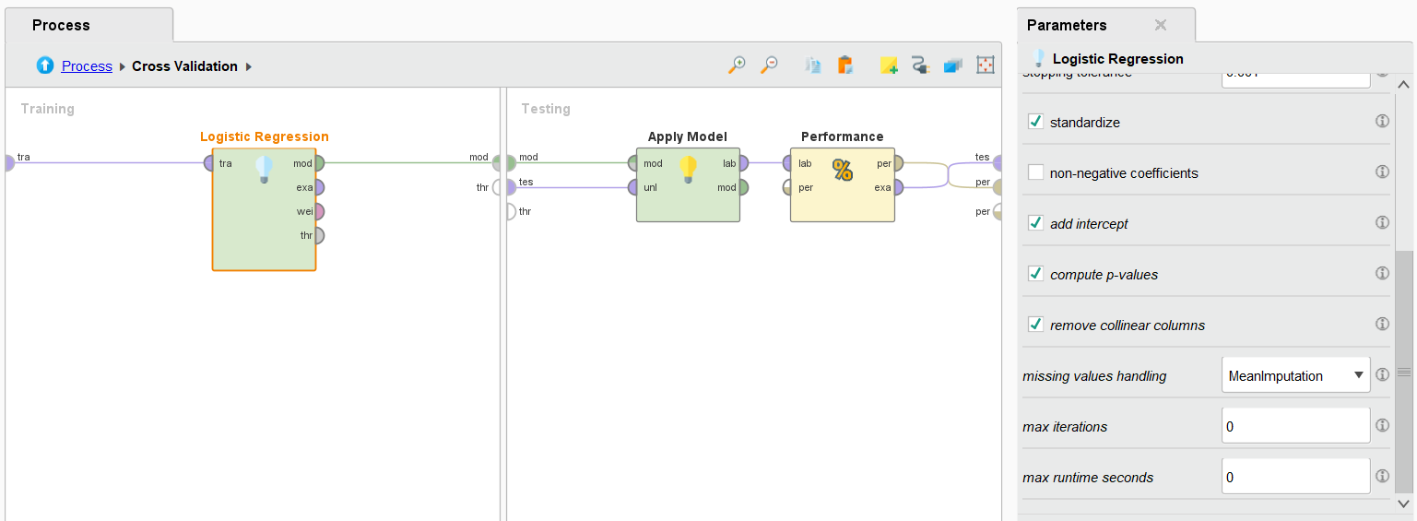
The screenshots show logistic regression parameters. Solver is set to auto to let the model select the best algorithm to produce better results. Reproducible is off to enable some randomness to check for different and possibly better results. It's disabled because random seed is already enabled in cross validation. Regularization is used to penalize the model for mistakes. It's off to allow the model to capture all relationships in the data, as overfitting wasn’t a big issue because cross validation was used and logistic regression generally has a low risk for overfitting. Early stopping is enabled after 3 tries and if changes are less than 0.001 so we can save time in case the model doesn’t progress much as in no real improvements. Standardization is enabled, so features can be scaled to make the model faster and more reliable. Another important parameter is removing collinear columns to remove highly correlated features and enable the model to properly learn rather than find an easy way out and cause overfitting. The model handles missing values by imputing with the mean.
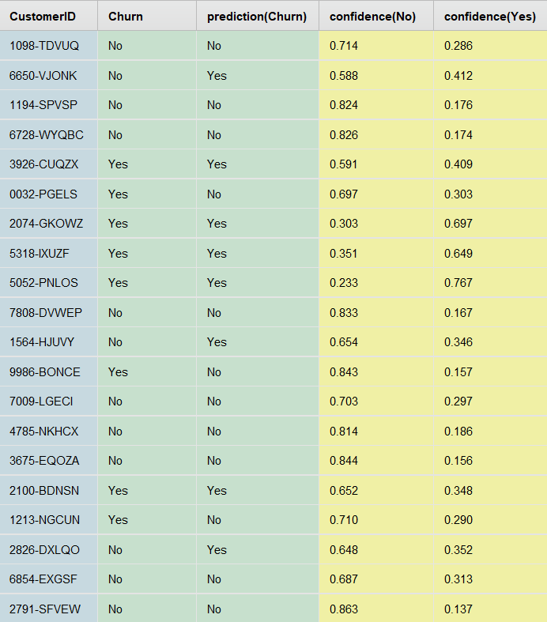

Random Forest
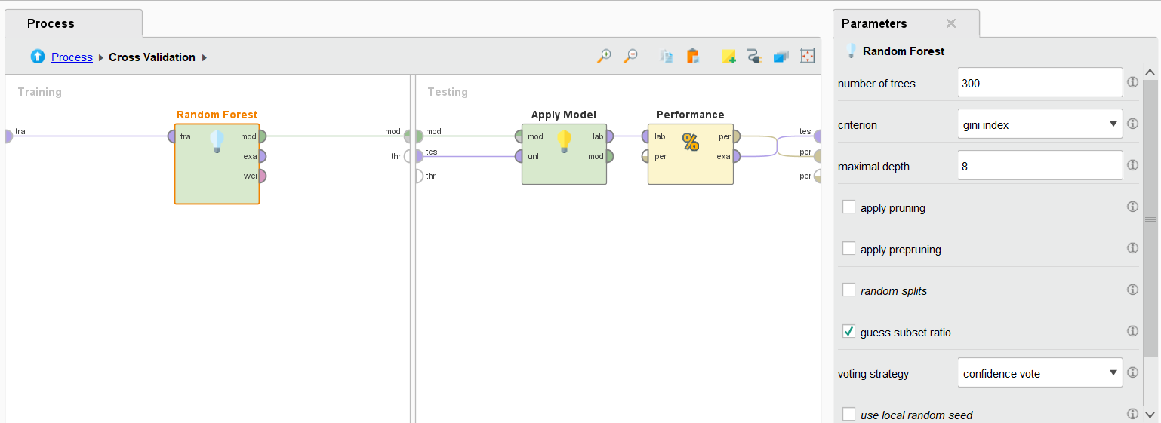
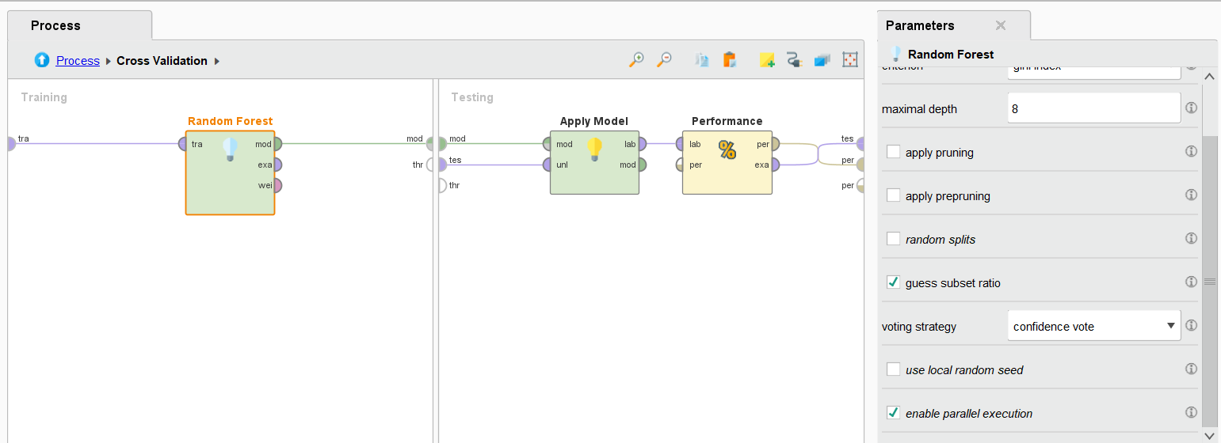Here, we show random forest parameters. Firstly, the number of trees is set to 300 for better accuracy, though it might slow down the model a bit, so there’s a tradeoff between speed and performance. For Criteration, we chose gini index due to its efficiency in helping the model to clearly separate churn vs no churn and is efficient for classification problems. Maximal depth was set to 8 per tree. Guess subset ratio was enabled for better diversity of trees and better feature selection per tree. Voting strategy is set to confidence vote to take the averages of all trees and use them. Parallel execution is enabled so trees are built at the same time to speed up the process.
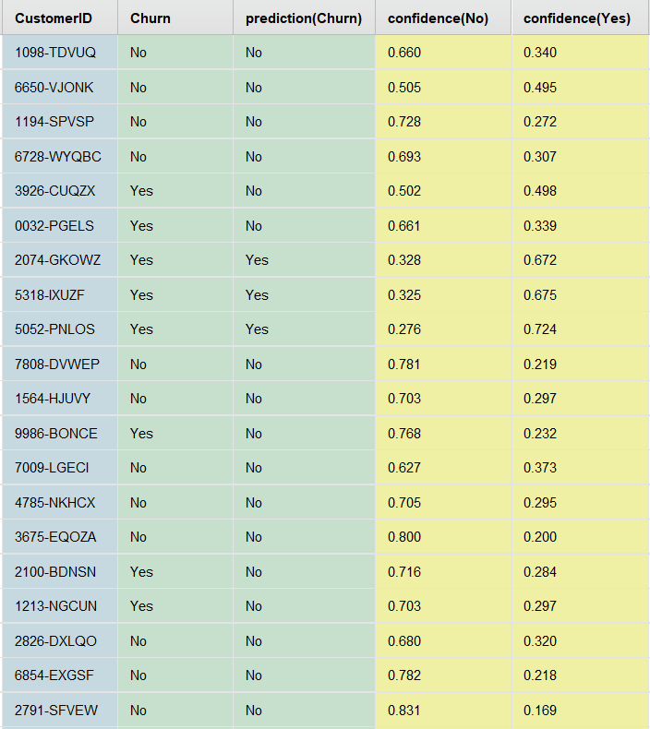

Performance Evaluation

Confusion Matrix

Logistic Regression
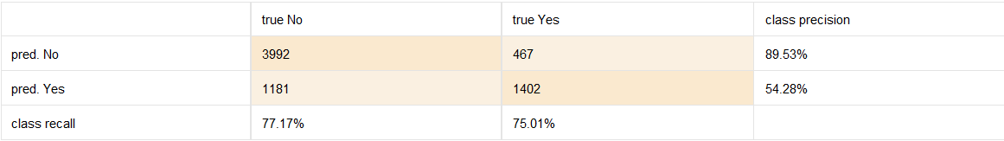
The Logistic Regression confusion matrix indicates that the model was able to identify a large number of churn customers (True Positives) and false negatives were kept as low as possible. This is significant since loss of churn customers may cause the company to suffer financial loss.

Random Forest
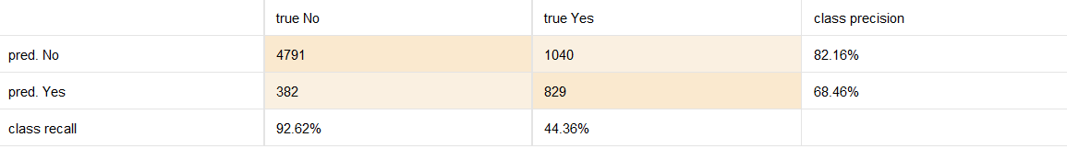
The confusion matrix of the Random Forest indicates that there are more True Negatives but also more False Negatives than the Logistic Regression. This implies that the model does not capture the additional churn customers, which makes it not very useful in retention strategies.

Accuracy
Logistic Regression | Random Forest
accuracy: 76.60% +/- 0.93% (micro average: 76.60%) | accuracy: 79.81% +/- 0.95% (micro average: 79.81%)
Random forest achieved a higher accuracy with 79.81% and logistic regression only gave 76.60%. This makes random forest better in terms of accuracy. Random forest is more reliable when it comes to capturing customer behaviors leading to churn. However, this does not necessarily make it more suitable for churn prediction, as recall is more important in this problem.

Precision
Logistic Regression | Random Forest
precision: 54.31% +/- 1.43% (micro average: 54.28%) (positive class: Yes) | precision: 68.51% +/- 3.05% (micro average: 68.46%) (positive class: Yes)
Random forest outperformed logistic regression massively with 68.51% precision. Although not too impressive, it still manages to be correct about who will churn more than half of the time.This suggests that the predictive reliability of identifying churn clients is moderate.

Recall
Logistic Regression | Random Forest
recall: 75.01% +/- 5.04% (micro average: 75.01%) (positive class: Yes) | recall: 44.35% +/- 2.14% (micro average: 44.36%) (positive class: Yes)
As for recall, logistic regression did far better than random forest, achieving a 75% recall. LR managed to correctly catch way more churners out of true positives and false negatives, whereas random forest had a less than acceptable performance, suggesting it misses many churners.

F1-Score
Logistic Regression | Random Forest
f_measure: 62.93% +/- 1.97% (micro average: 62.98%) (positive class: Yes) | f_measure: 53.82% +/- 2.23% (micro average: 53.83%) (positive class: Yes)
The F1 score suggests logistic regression has a better balance between precision and recall with 62.93% as opposed to random forest. This means logistic regression is more reliable overall to predict churn while lessening errors. The F1 score being high is very important to select the better model.

AUC
- Logistic Regression AUC: 0.844
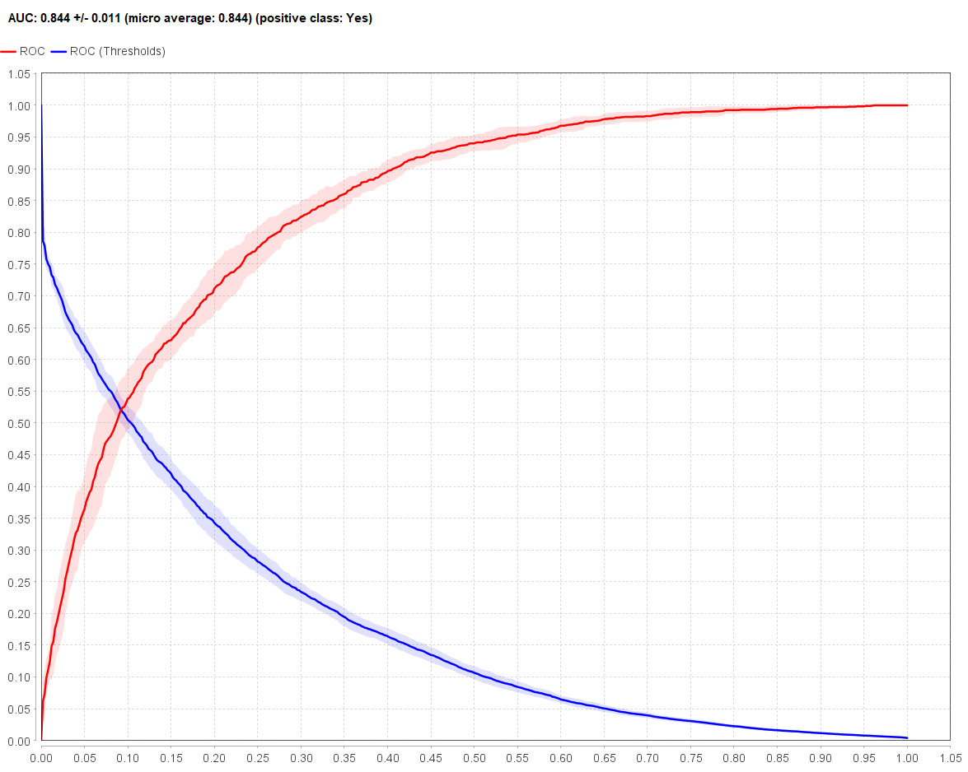
The AUC of LR indicates the ability of the model to differentiate between churning customers and non-churning ones. An increased AUC value implies that the model is more effective in correctly classifying both classes.

Random Forest AUC: 0.847
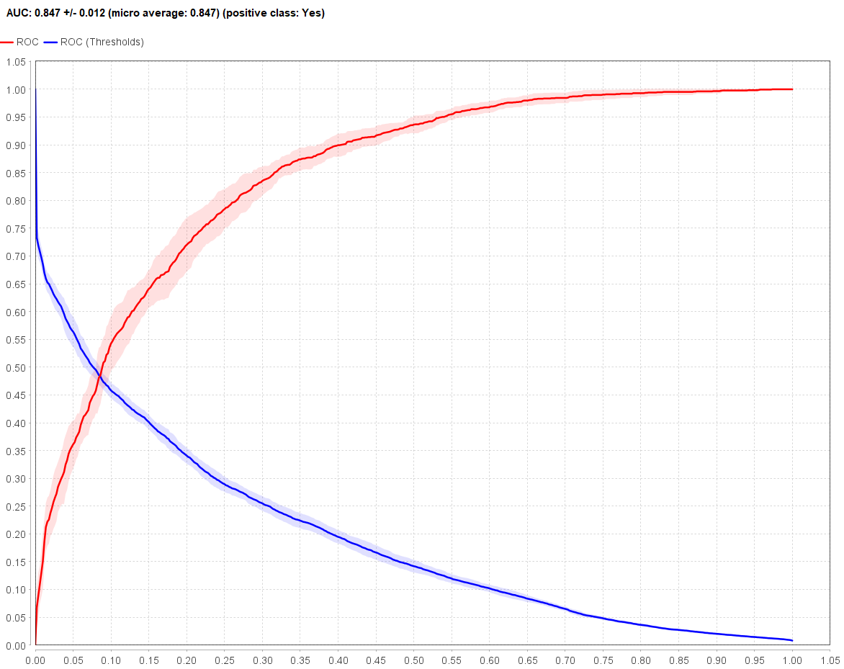
Random Forest AUC is used to estimate the ability of the model to differentiate between churn and non-churn customers. Whereas Random Forest is good in certain measures such as accuracy and precision, its AUC measure is slightly than that of Logistic Regression.
The AUC score for logistic regression is 0.844 and for random forest is 0.847; hence, both algorithms have almost equal AUC values. The high AUC scores suggest that the two methods have good discriminatory power, meaning both can effectively rank customers based on the likelihood of churn or no churn.
For a company like EmiratiTel, this capability is important since the organization can take proactive measures such as giving promotions and/or improving its services to prevent high-risk customers from churning.

Model Comparison
After looking at metrics for both models, we determined that logistic regression is the best model to predict EmiratiTel churn. This is because LR meets the project requirements, and has a higher recall indicating that it can catch way more churners than RF. It also has a better F1 score suggesting a more balanced model which makes it more reliable. It’ll positively impact the business as it’ll save EmiratiTel more costs on wasted marketing efforts to non-churners. It'll also help the company identify the churners better to take proactive measures to retain them. Even though random forest has a higher accuracy and precision, it still unfortunately misses many churners, and this can financially harm the company in the long run.
Metric | Logistic Regression | Random Forest
Accuracy | 76.60% | 79.81%
Precision | 54.31% | 68.51%
Recall | 75.01% | 44.35%
F1 Score | 62.93% | 53.82%
AUC | 0.844 | 0.847

- Business Insights
Our discoveries show that the logistic regression, can reliably predict the risk of customer churn. LR can help with decisions regarding customer retention. As observed: customers with low tenure, high monthly fees, less responsibilities, and month-to-month contracts are likely to churn.
Since these customers carry the greatest risk of losing money, they should be targeted by the retention strategy. In this case, EmiratiTel would move from a reactive approach to a proactive one. That is, rather than respond after customer churn occurs, the company can now prevent churn from happening.
This will help EmiratiTel with:
- Decreasing customer acquisition costs
- Concentrating resources on the riskiest customers
- Maximizing the value of customers
Even though LR is reliable, it should not replace human judgement in making retention decisions.
- Recommended Actions
Based on model predictions, EmiratiTel can now focus on identifying high-risk customers and implementing high retention strategies such as:
Giving them personalized offers and discounts. Customers who are young and single are often students and could use lower prices on services.
Packages tailored to their needs based on who they are. For example, customers with dependents can be offered family offers.
Creating loyalty programs and giving different offers based on tenure. Customers who stay longer enjoy more benefits, discounts, and gifts. This will help strengthen the bond between customer and EmiratiTel.
Customers who upgrade from a monthly to a yearly plan, and subscribe to more add-ons, get exclusive offers and the yearly cost per month becomes less than only monthly contract.

- Deployment Strategy
  - Real Time or Batch
For EmiratiTel, the better approach is to deploy the solution as batch processing. Predicting churn does not require instant action because decision making can be done in scheduled meetings with analysts and experts weekly. They can compile results generated during the batching process over a few days and make appropriate decisions based on data. Batch processing will also considered more cost-effective and efficient, reducing computing power and if their computing is done on the cloud, it’s cheaper to run jobs in batches rather than real time which requires constant computing power and higher costs.

  - Integration with CRM
The model can be integrated into EmiratiTel’s CRM system to help retain their customers. Probabilites generated by the model for churn can go on the customer profile, allowing for customer servie staff to locate high risk customers more easily and make the right call. They can also track the customer activity and quantify their interactions to make more accurate and personalized decisions.
Churn predictions can be used by CRM staff to determine high-risk customers and take preemptive measures, including calling customers directly, providing them with special discounts, and enhancing customer service. They are also able to track the interactions with customers and offer customer-specific solutions to the customers according to their needs to enhance retention.
Who benefits from model integration with CRM?
Persona | Use Case
Executives | View overall churn trends and KPIs
Marketing Team | Access list of high-risk customers for campaigns
Customer service | See churn risk when interacting with customers

  - Monitoring
Model performance needs to be continuously monitored to make sure that the model carries on producing the highest metrics. AUC, recall, and precision must be analyzed regularly to ensure performance doesn’t drop. Furthermore, variations in customer behavior and market dynamics might affect the model, so it’ll have to be updated consistently.
To build trust and support data driven decision making, the model outputs should include key drivers of churn like short tenure, contract type, monthly charges, and demographic of customers. This will help EmiratiTel’s team understand why customers are at risk, not just who is.
- Conclusion
The project effectively implemented the CRISP-DM approach to solve the problem of customer churn in EmiratiTel using machine learning. The research started with an understandable business problem, which was the challenge of retaining customers and a set of measurable success guidelines in line with business objectives.
The dataset was also thoroughly cleaned, transformed, and encoded with RapidMiner to guarantee excellent data quality and consistency through data understanding and preparation. Salient characteristics affecting churn were determined and the target variable was also well-defined to aid in predictive modeling.
Two machine learning models were created and assessed 10-fold cross-validation Logistic Regression and Random Forest. The models have been evaluated on various performance measures such as accuracy, precision, recall, F1-score, and AUC. The final model chosen was Logistic Regression because it is highly recalling, balanced, and has the capacity to accurately find high-risk customers.
The results indicate that machine learning can be useful in understanding the behavior of customers and can assist in making data-driven decisions. Depending on the findings, EmiratiTel will be able to engage in specific retention measures to minimize churn, streamline marketing activities, and enhance customer satisfaction.
Altogether, this project demonstrates that data analytics is essential to integrate with business knowledge to tackle real-life issues. Future research could be aimed at enhancing models’ performance, using more data sources, and constant monitoring of the model to adjust to evolving customer behaviors.

References:

Wikipedia contributors. (2025b, November 27). Customer attrition. Wikipedia. https://en.wikipedia.org/wiki/Customer_attrition

Huang, B., Kechadi, M. T., & Buckley, B. (2012). Customer churn prediction in telecommunications. Expert Systems with Applications, 39(1), 1414–1425. https://doi.org/10.1016/j.eswa.2011.08.024

Deepika Kumari, Santosh Kumar Singh, Sanjay Subhash Katira, Inumarthi V Srinivas, & Uday Salunkhe. (2025). Telecom Customer Churn Forecasting Using Machine Learning: A Data-Driven Predictive Framework. Metallurgical and Materials Engineering, 31(4), 922–929. https://doi.org/10.63278/1536

